**1. What is Dynamo DB ?**



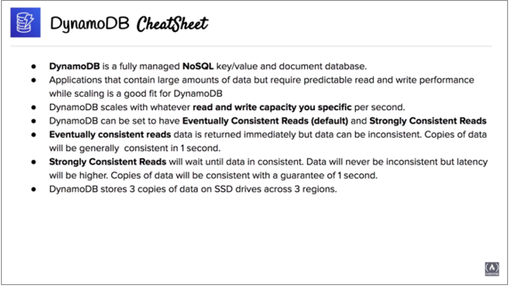

* It is cheaper to read compare to write so almost use Dynamo DB read to the database.
* It is use in web server , application etc.

**1.1** How to create Dynamo DB database ?

1. Aws management console **>** services **>** database **>** Dynamo DB **>** create .

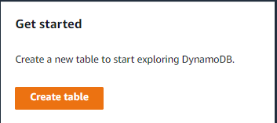



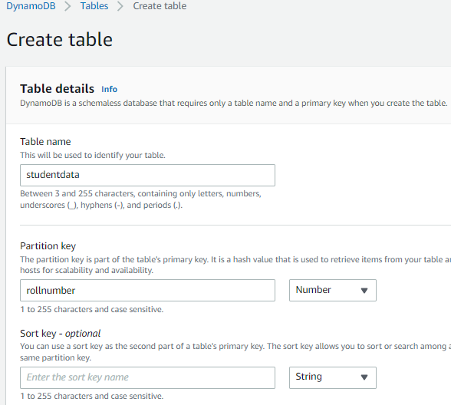

1. I select here default setting, it pre configured about Dynamo DB if is choose customize setting then can configure in all the setting

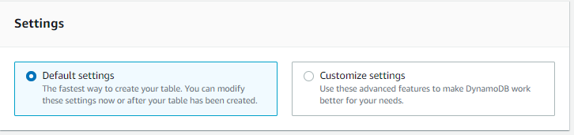



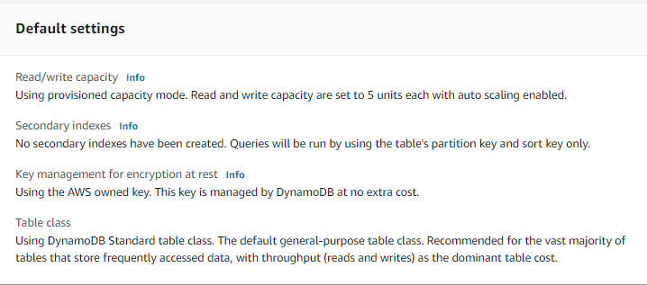



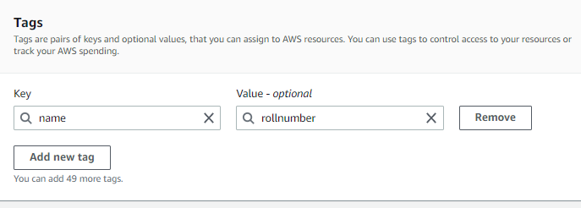

1. It successfully created (studentdata)

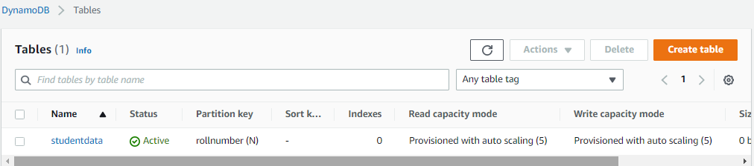



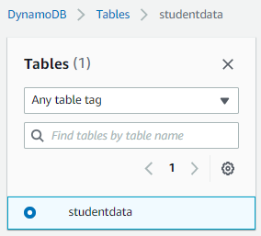

1. Here have create item

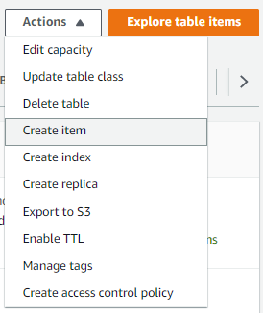

1. 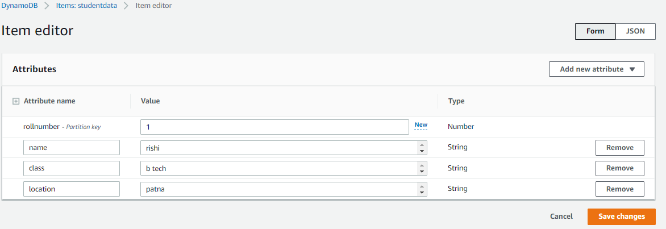
2. There is two items . we can find out by roll number or name. It case sensitive.

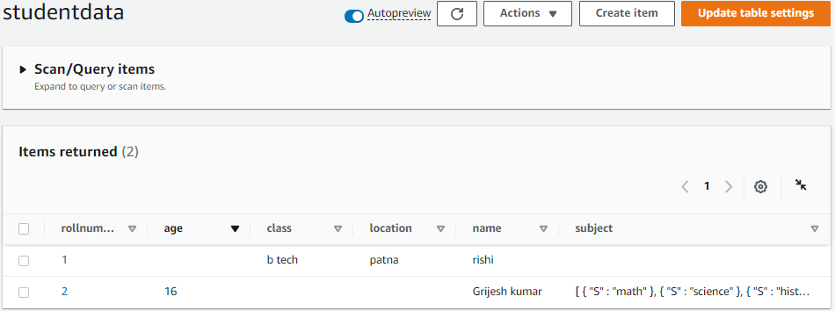

**Thank you**